# 实验三

## 运行结果

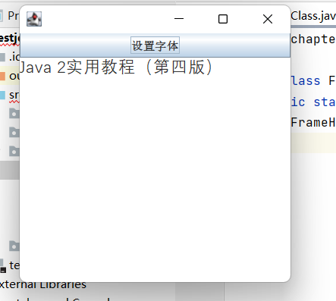

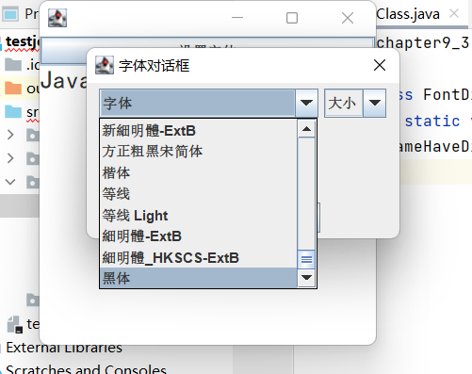

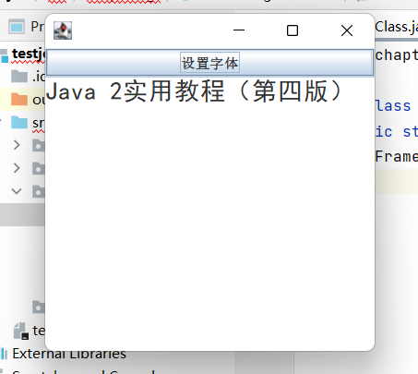

## 代码截图

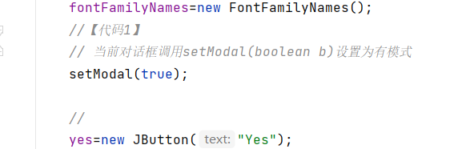

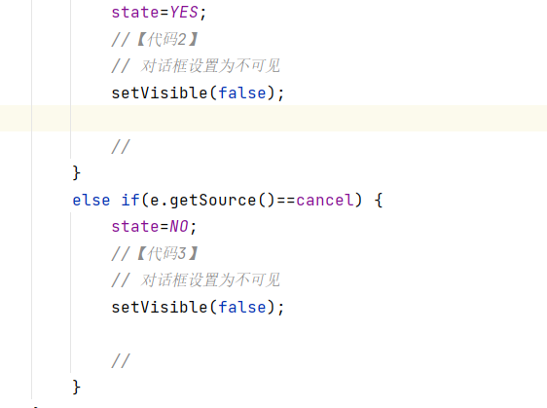

## 代码

package chapter9_3;

public class FontDialogMainClass {

public static void main(String args[]) {

FrameHaveDialog win=new FrameHaveDialog();

}

}

//

package chapter9_3;

import java.awt.GraphicsEnvironment;

public class FontFamilyNames {

String allFontNames[];

public String [] getFontName() {

GraphicsEnvironment ge=GraphicsEnvironment.getLocalGraphicsEnvironment();

allFontNames=ge.getAvailableFontFamilyNames();

return allFontNames;

}

}

//

package chapter9_3;

import java.awt.event.*;

import java.awt.*;

import javax.swing.*;

public class FrameHaveDialog extends JFrame implements ActionListener {

JTextArea text;

JButton buttonFont;

FrameHaveDialog() {

buttonFont=new JButton("设置字体");

text=new JTextArea("Java 2实用教程（第四版）");

buttonFont.addActionListener(this);

add(buttonFont,BorderLayout.NORTH);

add(text);

setBounds(60,60,300,300);

setVisible(true);

validate();

setDefaultCloseOperation(DISPOSE_ON_CLOSE);

}

public void actionPerformed(ActionEvent e) {

if(e.getSource()==buttonFont) {

FontDialog dialog=new FontDialog(this);

dialog.setVisible(true);

if(dialog.getState()==FontDialog.YES) {

text.setFont(dialog.getFont());

text.repaint();

}

if(dialog.getState()==FontDialog.NO) {

text.repaint();

}

}

}

}

//

package chapter9_3;

import java.awt.event.*;

import java.awt.*;

import javax.swing.*;

public class FontDialog extends JDialog implements ItemListener,ActionListener {

FontFamilyNames fontFamilyNames;

int fontSize=38;

String fontName;

JComboBox fontNameList,fontSizeList;

JLabel label;

Font font;

JButton yes,cancel;

static int YES=1,NO=0;

int state=-1;

FontDialog(JFrame f) {

super(f);

setTitle("字体对话框");

font=new Font("宋体",Font.PLAIN,12);

fontFamilyNames=new FontFamilyNames();

//【代码1】

// 当前对话框调用setModal(boolean b)设置为有模式

setModal(true);

//

yes=new JButton("Yes");

cancel=new JButton("cancel");

yes.addActionListener(this);

cancel.addActionListener(this);

label=new JLabel("hello,奥运",JLabel.CENTER);

fontNameList=new JComboBox();

fontSizeList=new JComboBox();

String name[]=fontFamilyNames.getFontName();

fontNameList.addItem("字体");

for(int k=0;k<name.length;k++)

fontNameList.addItem(name[k]);

fontSizeList.addItem("大小");

for(int k=8;k<72;k=k+2)

fontSizeList.addItem(new Integer(k));

fontNameList.addItemListener(this);

fontSizeList.addItemListener(this);

JPanel pNorth=new JPanel();

pNorth.add(fontNameList);

pNorth.add(fontSizeList);

add(pNorth,BorderLayout.NORTH);

add(label,BorderLayout.CENTER);

JPanel pSouth=new JPanel();

pSouth.add(yes);

pSouth.add(cancel);

add(pSouth,BorderLayout.SOUTH);

setBounds(100,100,280,170);

setDefaultCloseOperation(DISPOSE_ON_CLOSE);

validate();

}

public void itemStateChanged(ItemEvent e) {

if(e.getSource()==fontNameList) {

fontName=(String)fontNameList.getSelectedItem();

font=new Font(fontName,Font.PLAIN,fontSize);

}

else if(e.getSource()==fontSizeList) {

Integer m=(Integer)fontSizeList.getSelectedItem();

fontSize=m.intValue();

font=new Font(fontName,Font.PLAIN,fontSize);

}

label.setFont(font);

label.repaint();

validate();

}

public void actionPerformed(ActionEvent e) {

if(e.getSource()==yes) {

state=YES;

//【代码2】

// 对话框设置为不可见

setVisible(false);

//

}

else if(e.getSource()==cancel) {

state=NO;

//【代码3】

// 对话框设置为不可见

setVisible(false);

//

}

}

public int getState() {

return state;

}

public Font getFont() {

return font;

}

}